

New Patient Intake Packet

Name: __________________________________________
Date of Birth: __________________________________________
Family Physician: __________________________________________
Referring Provider: __________________________________________
Pharmacy: __________________________________________

This information is required by governmental programs (CMS) to improve care coordination and quality of care.
Birth Sex: ☐ Male ☐ Female ☐ Unknown
Sexual Orientation: ☐ Straight ☐ Gay/Lesbian ☐ Bisexual ☐ Prefer not to disclose ☐ Other
Gender Identity: ☐ Male ☐ Female ☐ Non-binary ☐ Prefer not to disclose ☐ Other

Today's Appointment
Is someone accompanying you to today's appointment? ☐ Yes ☐ No
If yes, please provide their name and relationship: ______________________________________________________

Office Use:
P | HR | RR | Temp | O2 | Height | Weight
Vital Signs:

Office Notes:

Medical History
Have you ever, or do you now have, any of the following conditions? Circle all that apply.
Acid Reflux | Diabetes- Type 1 | Psoriatic Arthritis
AIDS/HIV | Diabetes- Type 2 | Renal Failure
Anemia | Hay Fever | Scoliosis
Anticoagulant Therapy (blood thinner) | Hearing Impaired | Shingles
Anxiety | Heart Disease | Stomach Ulcers
Arrhythmia | High Cholesterol | Tachycardia
Atrial Fibrillation | Hyperthyroidism | Traumatic Brain Injury (TBI)
Autoimmune Disease | Hypoglycemia | Transient Ischemic Attack (TIA)
Bipolar Disorder | Hypoxia | Temporomandibular Joint Disorder (TMJ)
Bowel Disorder | Irritable Bowel Syndrome (IBS) | Upper GI Bleed
Cancer | Insomnia | Varicose Veins
Chronic Kidney Disease | Liver Disease | Vitamin B12 Deficiency
Clotting Disorder | Lower GI Bleed | Vitamin D Deficiency
Colostomy | Memory Impairment | Wears Hearing Aid
Complication of Anesthesia | Menopause | White Coat Hypertension
Dementia | Migraine Headaches | Other:
Depression | Oxygen Dependent

Medication Allergies
An allergy is your immune system reacting and can be dangerous—things like hives, swelling, or trouble breathing. Side effects are expected reactions like nausea or sleepiness—they’re uncomfortable but not dangerous.
Medication Allergy | Reaction

Pain Location
Please shade or circle the area where you experience the most pain, numbness, tingling, or discomfort.
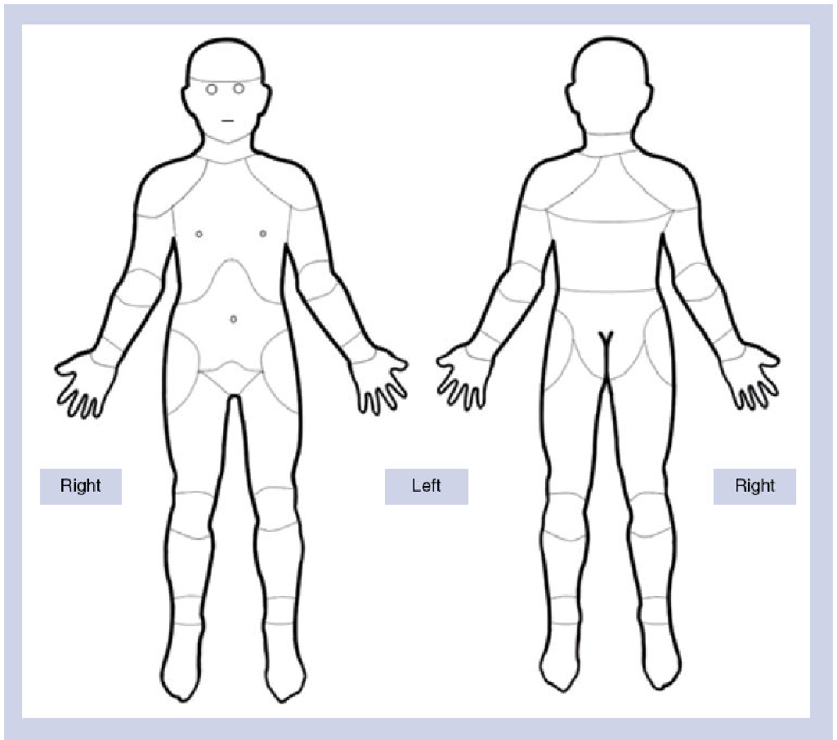
Pain Rating
Please rate your pain
Current Pain Level: ______ /10
Best Pain Level: ______ /10
Worst Pain Level: ______ /10
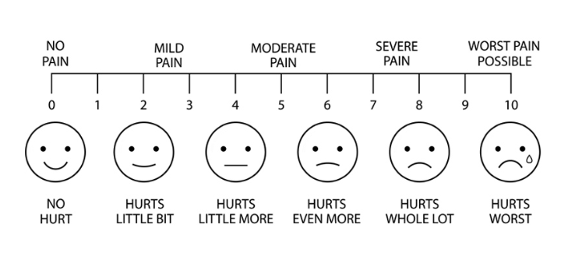
Pain Details
(check all that apply)
Pain Description: ☐ Dull ☐ Aching ☐ Throbbing ☐ Cramping ☐ Sharp ☐ Burning ☐ Shooting ☐ Stabbing
☐ Tingling
Pain Type: ☐ Acute (less than 3 months) ☐ Chronic (more than 3 months)
Pain Stability: ☐ Stable ☐ Exacerbated ☐ Worsening ☐ Improving ☐ New Onset
Pain Frequency: ☐ Constant ☐ Intermittent ☐ Frequent ☐ Occasional ☐ Infrequent
Time of Day Pain is Worst: ☐ Morning ☐ Afternoon ☐ Evening ☐ Morning & Afternoon ☐ Morning & Evening
☐ All Day
What caused the pain? ☐ Gradual onset ☐ Auto accident ☐ Work accident ☐ Injury at home ☐ Other:

Additional pain details: _____________________________________________________________________

Aggravating Factors
(check all that apply)
☐ Heat ☐ Cold ☐ Physical Activity ☐ Sitting ☐ Standing ☐ Walking ☐ Running ☐ Stairs ☐ Bending
☐ Twisting ☐ Stress ☐ Light Touch ☐ Sexual Activity ☐ Weather
Other aggravating factors: ____________________________________________________________________

Current Conservative Care or Previous Treatments
Conservative care refers to non-surgical treatments used to manage pain and improve function before considering more advanced procedures or surgery. These treatments may include therapies, medications, and lifestyle modifications aimed at reducing pain and improving mobility.
Treatment | Yes | No | When (month/year) | Frequency  5-10 minutes, 15-30 minutes, greater than 30 minutes, once a week, once a month, etc.
Physical Therapy | ☐ | ☐
Chiropractic Care | ☐ | ☐
Home Exercise Program | ☐ | ☐
Assistive Devices | ☐ | ☐
Pain Medications | ☐ | ☐
Ice/Heat Therapy | ☐ | ☐
Acupuncture | ☐ | ☐
TENS Unit | ☐ | ☐
Behavioral Health | ☐ | ☐
Osteopathic Manipulation | ☐ | ☐
Therapeutic Injections | ☐ | ☐
Other | ☐ | ☐

Additional Symptoms
Additional Details | Yes | No | Onset (month/year) | Additional notes
Does your pain affect your bowel or bladder function? | ☐ | ☐
Are you taking your medications as prescribed? | ☐ | ☐

Review Of Systems
(check all that apply)
Constitutional
☐ Fever | ☐ Chills | ☐ Weight loss | ☐ Fatigue
Cardiovascular
☐ Chest pain | ☐ Palpitations | ☐ Swelling in legs
Respiratory
☐ Shortness of breath | ☐ Cough | ☐ Wheezing
Gastrointestinal
☐ Nausea | ☐ Vomiting | ☐ Diarrhea | ☐ Constipation

Genitourinary
☐ Painful urination | ☐ Frequent urination | ☐ Blood in urine
Neurologic
☐ Headaches | ☐ Dizziness | ☐ Numbness | ☐ Weakness
Musculoskeletal
☐ Joint pain | ☐ Back pain | ☐ Muscle pain | ☐ Stiffness
Psychiatric
☐ Anxiety | ☐ Depression | ☐ Sleep problems
Skin
☐ Rash | ☐ Itching | ☐ Skin changes
Endocrine
☐ Heat intolerance | ☐ Cold intolerance | ☐ Excess thirst
☐ Heart Disease | ☐ Heart Attack | ☐ Stroke
☐ High Blood Pressure | ☐ Irregular Heart Rate | ☐ Chest Pain
☐ Asthma | ☐ Emphysema | ☐ Kidney Problems
☐ Thyroid Problems | ☐ Seizures | ☐ Diabetes
☐ Arthritis | ☐ Cancer | ☐ Bleeding Easily

Current Medications
If you have a printed medication list from your pharmacy or primary care physician, you may attach it instead.
*If you have additional medications to add, please write on the back of this page.
Medication Name Example: Meloxicam (Mobic) | Dose 15mg | Frequency Once Daily

Family History
Please provide significant medical conditions.
Mother:
Father:
Other Immediate Family Members:

Social History
Tobacco Use:
☐ Current Smoker | ☐ Former Smoker | ☐ Non-Smoker

If current smoker, when did you start smoking (year)? __________
If former smoker, when did you quit (year)? __________

How often do you smoke cigarettes? | ☐ Everyday | ☐ Some days, but not everyday

How many cigarettes per day do you smoke? | ☐ 5 or less | ☐ 5–10 | ☐ 11–20 | ☐ 21–30 | ☐ 31 or more

How soon after waking do you smoke? | ☐ Within 5 minutes | ☐ 6–30 minutes | ☐ 31–60 minutes | ☐ After 60 minutes

Are you interested in quitting? | ☐ Ready to quit | ☐ Thinking about quitting | ☐ Not ready to quit

Do you use other tobacco products (snuff, pouches, chew)? | ☐ Yes | ☐ No

Alcohol Screening:
Did you have a drink containing alcohol in the past year? | ☐ Yes | ☐ No

How often did you drink alcohol in the past year? | ☐ Never | ☐ Monthly or less | ☐ 2–4 times a month | ☐ 2–3 times a week | ☐ 4 or more times a week

How many drinks did you have on a typical drinking day in the past year? | ☐ 1–2 drinks | ☐ 3–4 drinks | ☐ 5–6 drinks | ☐ 7–9 drinks | ☐ 10 or more

How often did you have 6 or more drinks on one occasion in the past year? | ☐ Never | ☐ Less than monthly | ☐ Monthly | ☐ Weekly | ☐ Daily or almost daily

Recreational Use
Do you use any recreational drugs? | ☐ Yes | ☐ No
Have you ever used needles to inject drugs? |  |  | ☐ Yes | ☐ No

Caffeine Intake:
Caffeine intake | ☐ None | ☐ 1–2 cups/day | ☐ 2–3 cups/day | ☐ 3–4 cups/day | ☐ More than 4 cups/day

Marijuana Use:
Do you use marijuana? | ☐ Yes | ☐ No
Do you have a medical marijuana card? | ☐ Yes | ☐ No

Surgical History
Surgery (including implants, cataracts, etc.) | When (month/year)

Hospitalization
Have you been hospitalized within the past 12 months? ☐ Yes ☐ No
If yes, please describe the reason and date:
__________________________________________________________________________________________
__________________________________________________________________________________________
Additional Questions
Any active infections resulting in taking antibiotics? ☐ Yes ☐ No
Any change of pregnancy? ☐ Yes ☐ No ☐ N/A
Diagnostic Imaging
Test | Area scanned | Facility | When (month/year)
X-ray
MRI
CT Scan
Other

Brief Pain Inventory (BPI)
Patient Pain & Function Assessment

Pain Interference Ratings 0 = Does not interfere 10 = Completely interferes
Circle one number for each item below representing how much pain has interfered with your life in the past week.
General Activity | 0 | 1 | 2 | 3 | 4 | 5 | 6 | 7 | 8 | 9 | 10
Mood | 0 | 1 | 2 | 3 | 4 | 5 | 6 | 7 | 8 | 9 | 10
Walking Ability | 0 | 1 | 2 | 3 | 4 | 5 | 6 | 7 | 8 | 9 | 10
Normal Work  (at home or outside the home) | 0 | 1 | 2 | 3 | 4 | 5 | 6 | 7 | 8 | 9 | 10
Relations With Other People | 0 | 1 | 2 | 3 | 4 | 5 | 6 | 7 | 8 | 9 | 10
Sleep | 0 | 1 | 2 | 3 | 4 | 5 | 6 | 7 | 8 | 9 | 10
Enjoyment of Life | 0 | 1 | 2 | 3 | 4 | 5 | 6 | 7 | 8 | 9 | 10

Please list any treatments or medications you are currently using for pain: ________________________________________________________________________________________
________________________________________________________________________________________

Pain Relief From Treatments/Medications
In the last week, how much relief have your pain treatments or medications provided?
Circle the percentage that best reflects your relief:
(No relief) 0% 10% 20% 30% 40% 50% 60% 70% 80% 90% 100% (Complete relief)

Reminders

Appointment Checklist
Please bring the following items to your appointment:
☐ Photo ID
☐ Insurance Card
☐ Co-pay / Payment Method
☐ Current Medication List
(If you bring a list, you do not need to complete the medication section in this packet.)
☐ Relevant Medical Records
(Please bring any imaging reports or outside records, if available.)

Arrival Time
Please arrive15 minutes prior to your appointment. If you are unable to complete your new patient paperwork ahead of time, please arrive 30 minutes early.

Thank you for your time and cooperation—we look forward to seeing you at your appointment.

